OS Assignment 1
Talal Ali 24k0863

Step 1
Step 2:
Step 3:
Step 4:
Step 5:
Step 6:

Step 7:
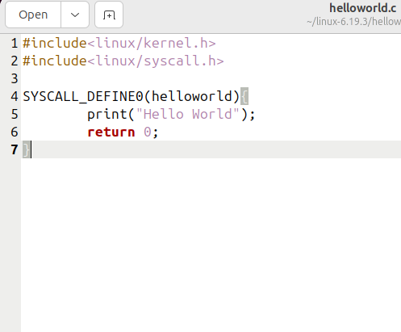
Step 8:

Step 9:
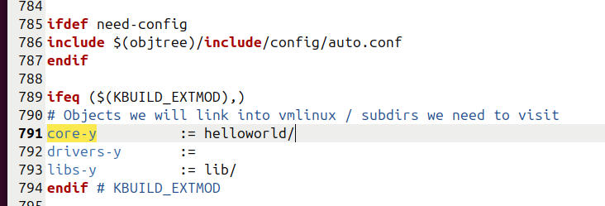
Step 10:
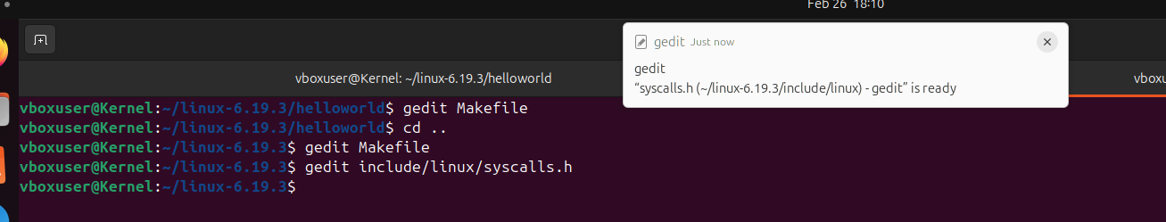
Step 11:
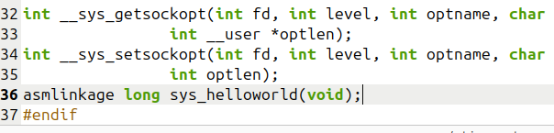
Step 12:
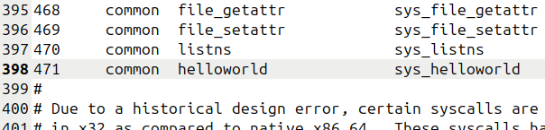
Step 13:
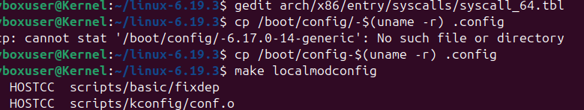
Step 14:
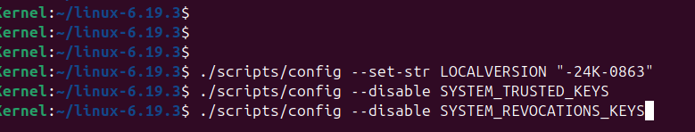
Step 15:
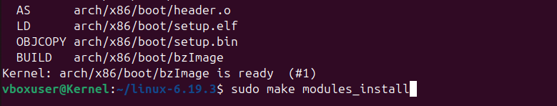
Step 16:
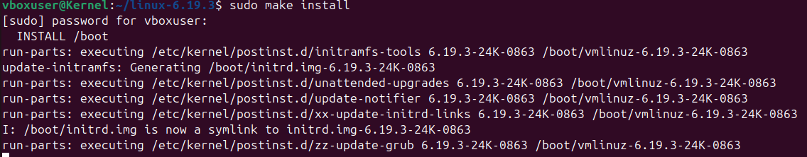
Step 17:
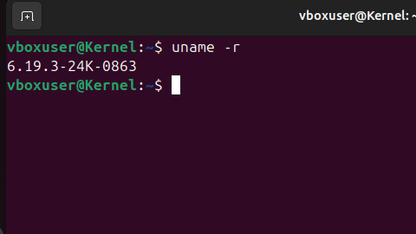
Step 17:
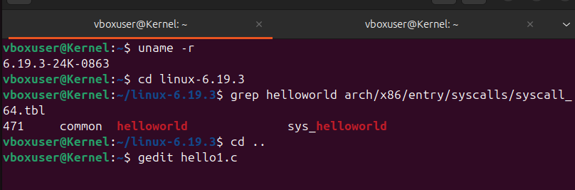
(System call still exists)
Step 18:
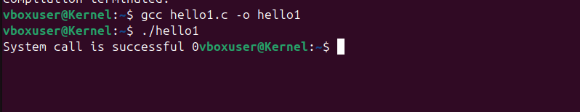
(System call is successful as it is =0)
Step 19:
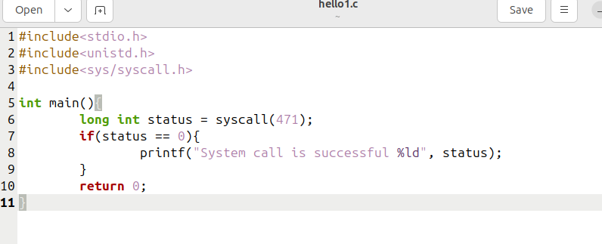
(Call is running as per code)

